Plymouth Harriers
Autumn 5

Plymouth Harriers Autumn 5 is a two-lap, 5-mile course, which starts and finishes inside Central Park at the Central Park Community Sports Hub. The course runs along paths within the park and on local roads around the perimeter of the park. It is undulating but also has downhill and flat sections!
The route affords you views of the October autumnal colours in and around the park.
Registration will be at the Central Park Community Hub. There are also toilets and changing facilities available and race participants will be able park in the Plymouth Argyle Park & Ride car park. Drinks will be available for purchase. A cake stand will also be in situ supplying an array of home-made cakes for purchase.
Entry to the event can be made on the Run Britain site via the following link: https://www.runbritain.com/entries/EnterRace.aspx?evid=7cb507cc595f&erid=7ebd0ec8586b
Prizes (one per athlete): 1st, 2nd, 3rd male and female, 1st MV and FV categories, 1st mixed affiliated team (6 to count)
Race medal also included for all finishers.
The course has been measured by Association of UK Course Measurers (course number 23/344) and the event has received a licence from Run Britain – licence number 2023-45980.
Plymouth Harriers are supporting local charity Provide Devon for 2023/2024. Provide Devon is a Christian charity providing food and other essentials to local people at crisis point. Using a combination of fresh produce and donated food from retailers, businesses and the local community, a food parcel can be provided to referral agents within hours. The charity provides a rapid response, as often the people they are feeding will have been experiencing food insecurity for some time. Requests for support may be due to finances, mental health conditions, crime or violence, bereavement or a sudden change to circumstances. The charity’s aim is to give individuals, the majority of which are children and young people, immediate relief from hunger when they have no other options available.

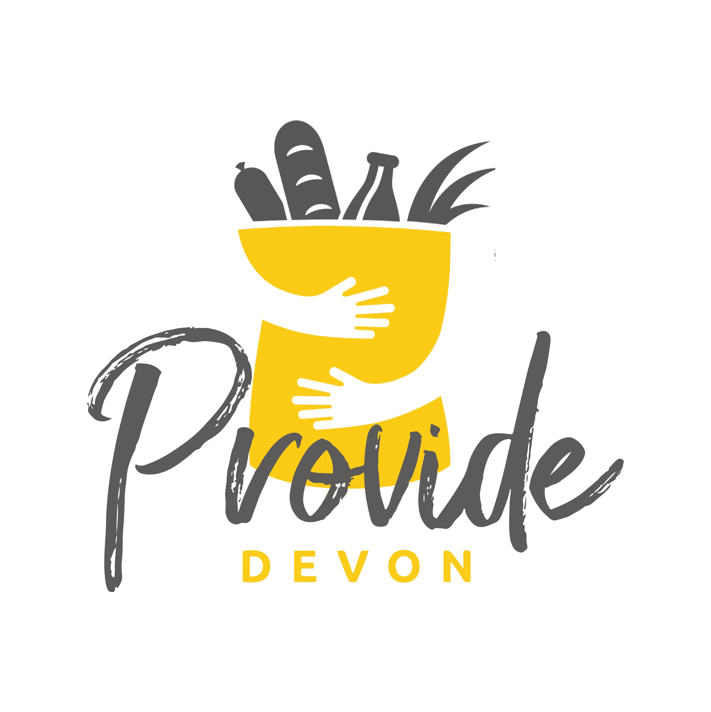
We would also like to thank our sponsors Pilates with Lorna and KE Sports Therapy for supporting our event:

